PROJECT REPORT
  - Introduction
  - OVERVIEW
In our project we includes then different types of crops and their area of production and their respective seasons
Purpose
This project is used to known about the crop production in different year duration. we can achieved the growth of the agriculture by using this project.
Problem definition & decision thinking
Empathy map
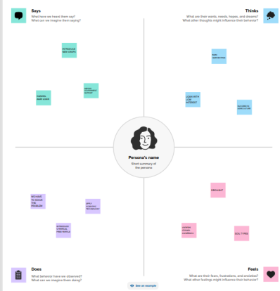
Brainstormimg map
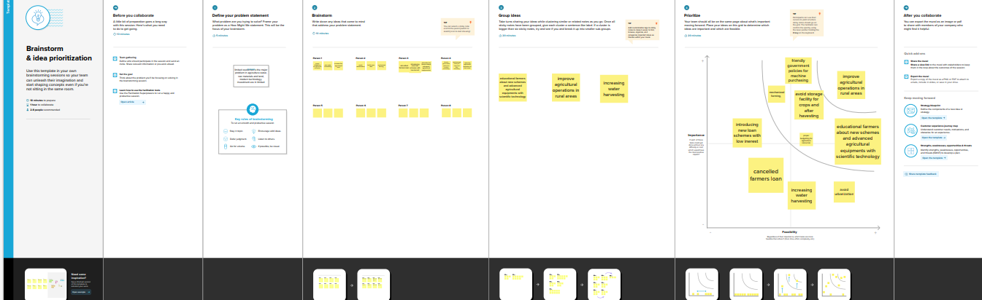

Result
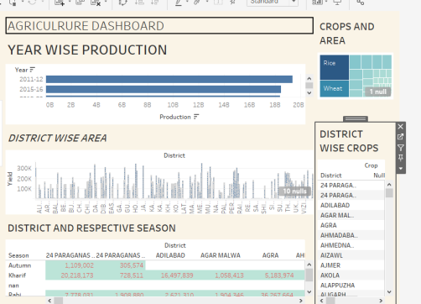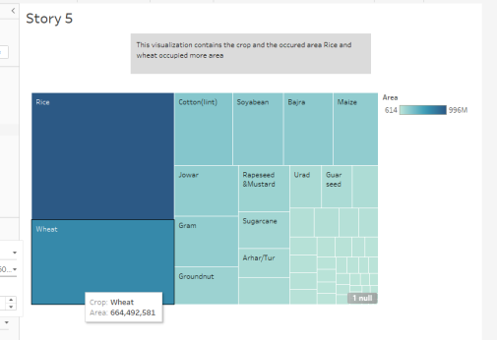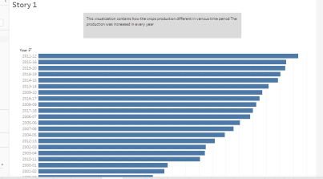

  - Advantages and disadvantages
This project contains all details including different crops and their production area, yield and various season in different districts.
It has some simple problem to solving the agricultural drawback of our country we could not discuss about the problem.
  - Applications
Our project is helpful to analyze the correct problem in agriculture field and useful to find which crop production s are low in area wise and season wise. The agriculture sector focuses on food production and supplies food to feed a country's growing population.
As a result, the agriculture sector is capable of meeting nearly all of its population's food requirements by developing a rigorous plan to increase the creation of foodstuff.
Conclusion
Agriculture has given so much to society. But it has its own pros and cons that we can't overlook. Furthermore, the government is doing his every bit to help in the growth and development of agriculture; finding the problem in agriculture and the ideas to solve all the problems.
Future scope
Efficient markets. Irrigation augmentation and management.
Agri-credit and crop insurance is useful to economic growth of the farmers
Adoption of new technologies it helps to increase the production
Enhancement of soil quality. Find the proper crop planting in correct seasons.

